**Requirement Understanding Document:**

**Project Overview:**

This project is basically is targeting the users like Real Estate agents who call up for a marketing company like DPI, whenever they want to sell any property. Therefore, before they sell the property, they engage these marketing teams to go and capture the photos, videos, create floor plans and send it back to the agent.



**Operational Flow of the system (User End)**



**Operation Flow diagram (Admin End)**

Company is the terminology used for the real estate agents company. When the real-estate agent sells a property they engage a marketing company like DPI to go and take photos, video, write words about the property, create floor plans for which are then sent back to the agent.

**Product Management**

Product is the terminology used to represent the services that will be provided by marketing company like DPI to the real estate agents/ companies. Products and Services can be used interchangeably.

The product viewed in the system will be transferred from XERO system, where these products already exists. They cannot be created or deleted but only be edited/viewed. The product set up would consist of things like associating a color code with each of the product, which will help the users to recognize the product’s events. It will have an Event title, event color, event duration, email Id to whom the mail to go if the request is for that particular product, etc. As soon as the color is been associated for a product, a “Create event” flag will be turned ON and an event will be created.

Questions:

* What will “event title” attribute consist of?
* CK> This is the title of the google event that will be required to be scheduled.
* What values will it have?

CK> Text values

* How to decide whether a company has the ability to buy a particular product or not?
* CK> A company needs to be associated to the Product for it to have the ability to Order It. This is why I have defined it having the On/Off control.
* What is the concept of group & sub-group?

If you have a look in the new order form, the user must select Photography (Group) before it displays the services offered in Photography. Within Photography (Group) there are sub groups (Day, Dusk, Prestige). These subgroups contain the services that the customer orders.

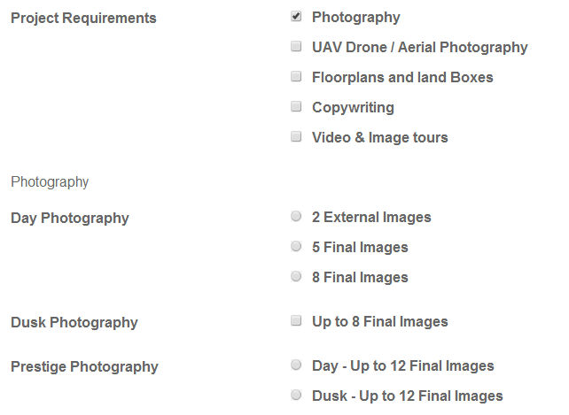

* What is the logic to calculate the pricing for the services asked for? How is it been calculated?

A product is issued a price. Not sure what you are talking about. There are no complex pricing rules, just sum price of products on an order.

**User Management**

In this system, there would be three types of users:

* External users (Clients/company)
* Internal Users (Staff)
* Admin (Complete system will be accessible)

Depending upon the roles assigned to the users, it will be decided as which functions they should be allowed to edit. The admin will be responsible to create, update, activate, deactivate users and also update the password on behalf of the user. The admin should also be able to view the list of users in the system.

Question: What is the “total spent” column in the contact user’s list?

We wouldn’t need this field, just normal user fields.

The system should allow the super administrator user to view/edit existing records in the Company table.

* **External Users:**

The External user needs to log on to the application to post their request to ask for a service. Only the authenticated users will be able to login to the application. If they are not able to login, they can click on the “Forgot password” link, which would be given on the login page. On click of this link, the system will send the user a link to reset their password.

Questions: How are the users authenticated? What is the authentication logic?

Validate if the user exists, check email/password and the user is active.

As soon as the user/company logs on to the campaign Track Application, they can post their new job order from there, asking for the services that DPI provide. There is a background process running continuously, would interpret these details in an automated email (in the html format) and send it to DPI services, informing them about this new order.

CK > No, only the Campaign Track system will generate an email and send it to the [dpi@zerofootprint.com.au](mailto:dpi@zerofootprint.com.au) mailbox. If an external user creates a new order via the front end, it will be directly stored in the database and an email confirmation will be sent to the external client.

As per the details in the html email generated, in XERO accounting system, which is an accounting package for DPI, an invoice is to be created using this email. **(Task 1 to be done)**

CK > The external windows service that currently posts invoices to XERO based on emails received from Campaign Track. Create Invoice flag will also post the new invoices to XERO based on the Company.

As the client logs on to the web application, they would see their profile already created by the admin team. They can search for a company to whom the order is to be sent, they can **create a new order**, or could **track their order status** or could **update their profile**. If they choose to create a new order, then the background process in Campaign track application will send an automated job order email to the DPI services.

CK > Once the external user authenticates, they do not need to search for a company. They will only be sourcing services exclusively from DPI, so no company search is required for external users.

Questions**:**

* Do you need a web application which will be integrated with the Campaign tack application and do the tasks

CK > No further integration with Campaign track is required.

* Do we need to provide a registration form on the website application for the users to register, or the admin will create the user & pass on the details to the users, using which they will be able to log in to the application.

CK> Administrators will create the user accounts for all user types.

* Creating a New Order: When creating a new order, the form would have the project & the other related details, the list of services (photography/ UAV drone/ Aerial Photography/ Floor plans and land boxes/ Copywriting/ Video & Image Tours) the provider can provide with, and it would also have the “property date” which would let the provider know till when the client needs the property in ready condition.

Questions: (“What is property to have custom website?” field, what is its significance from the business point of view and not system point of view?)

CK> This is a service, just like photography is. They create a website specifically for the property.

* Job Tracking: The users can track the status of the jobs already posted. The status mentioned will be in read only format for the external users. However, the internal users will have the control of the job tracking. They can update the status of the job as “job complete”, which were assigned to them. In addition, they can upload the files (digital assets) that have been produced as a result of the job. Once the job is been completed, it is been removed from the list of active jobs, in the system. Time line will be displayed that tracks movement of calendar items from a staging calendar, to individual resource
* Updating the client profile: The client will be able to update the profile as per requirement.

**Admin End:**

The orders created will be submitted by the users and received by the admin, in the admin panel. In the backend, the admin will be having the access to the complete system. The admin will be able to manage the product, companies, orders, contacts, job scheduling and job tacking etc.

Questions:

* What would be have in contacts

“Contacts” is just a grouping of users, external users, staff.

* What is a job scheduler? What is its working and significance?

The scheduler is where they would allocated unscheduled jobs to staff members to do this work.

* **Admin users:** The admin users will be able to view the whole list of new orders received. He will be assigning the jobs to the internal users as per the availability. The admin will be having a panel where they would be able to view the list of unscheduled jobs, list of users as per the unscheduled jobs and who can perform the unscheduled jobs, and buttons showing the services as per the company selected.

**Questions:** As per the power point presentation document sent, slide no. 12, displays some values against the user names. What does these values signifies?

**This is only an example of layout.** It should list the columns above.

* On the pane next to it, will be will be having the list of users in the company and their schedules displayed, so that the admin can assign the job to them as per their availability. As soon as the job is been assigned to the users, a task (event) is been created in the google calendar against the selected user for the selected time-duration on that date.
* Job Tracking: The property address will be listed and the services to be asked for the said property address will be displayed beside the property, and then will be displayed the status for each of the service asked for the property.
* Upload: This functionality will help the internal users to whom the job was been assigned, to upload the related documents to the clients.

**Questions form the Excel (Requirements. xlsx) that you have sent previously to Onkar:**

1. As per point no. (15) – Product Management - The super administrator user should be able to assign 1 or more companies to the Product. But, as per our document, we are going to refer the services from only one company i.e. DPI. So, aren’t these two statements contradicting each other.

Slide 16, when clicking on a Product, the user should be able enable, disable these products for companies. We need 1 (Product): M (Companies)

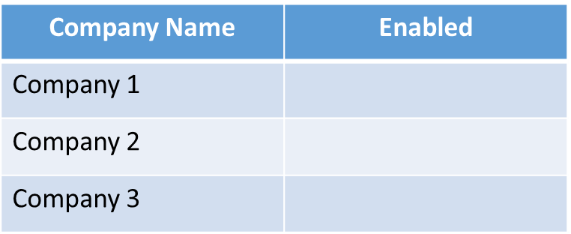

Note: The points highlighted in **RED** color are the queries. Kindly answer them.

|  |  |  |  |  |  |  |  |
| --- | --- | --- | --- | --- | --- | --- | --- |
| 1) | What is an event? what happens when event is created? | | | | | | |
|  | Who creates it? OR if system creates it, at what point does it gets created?  A job comes in. Some are allocated to resources (internal users) because they are future dated based on the required date specified in the order.  Jobs some in via either the automated Campaign Track email, or a job that an external user creates.  These jobs that require scheduling are then moved to an internal users calendar, hence creating an event in the calendar. | | | | | | |
|  | **My Assumption:** An event gets created, whenever the admin assigns any unallocated task to the particular user. The details that are stored for an event are: | | | | | | |
|  |  | The user for whom the event is created, the order for which the event is created, the task name/ title of event, start date & time, end date & time, status of the job allocated. | | | | | |
|  |  | Once the job is been completed by the user and the status is been changed to "Job Completed", then the event in the database, gets closed against the said order it and said event title. | | | | | |
|  |  |  | |  |  |  | |
| How to decide whether the product/ service is to be shown to the company?  There is a relationship stored in the db between a company and a product as documented by the iOS on off control which I specified to use. If its on for that company, then the company can order that product.  As documented in the database documentation these fields exist. | | | | | | |  |
|  |  |  | |  |  |  | |
| 3) | what is the use of create invoice, and create event flag? | | | | | | |
|  | **My assumption:** There is a flag saying "CreateInvoice" in the Company table. If it is set as "1", then whenever the new order is been generated, an invoice will be created for the same order in XERO accounting  Yes this is correct. We have discussed this. | | | | | | |
|  |  | system. Where will these two flags be set? | | | | | |
|  |  | But as per slide 11, you have asked to design the switcher control as per shown. So, do you want the control for "creation of invoice" flag on the UI end, so that whenever the user wants, they | | | | | |
|  |  | can switch ON/ OFF the switcher for this flag  Yes this is correct. We have discussed this. | | | | | |
|  |  | Similarly, for create event flag, if the event flag is "1", then event is been created against that particular company, but if the event flag is "0", does it mean that no event would be created for the | | | | | |
|  |  | said company, whenever the unallocated jobs are assigned to the internal staff users? | | | | | |
|  |  | Do we need to give the control (on the UI) to switch ON/ OFF the flag for create event, as per slide 11  Yes this is correct. We have discussed this. This is part of phase 1 which already has been implemented. | | | | | |
|  |  |  | |  |  |  | |
| 4) | Are allowing multiple people to logon through one company i.e. multiple people from same company can operate the account and post new orders | | | | | | |
|  | As per the excel sheet "Requirements", the external users can be associated with the more clients/company - req. 3 | | | | | | |
|  |  |  |  |  |  |  |  |

Yes this is correct. 1 external user will be associated to 1 company.

5) As per PPT, slide no. 23, if the user created is of user type = internal user, then he can be associated with the available calendars list in the calendar table, and store the user associated with it.

**Queries:** From where the calendars would be added in the system? Does it mean that one calendar is associated with multiple users? If this is the case, then how can we track the jobs for different users?

6) In the order-listing screen, what is order value, name and type.

**My assumption:**  For Slide 26 as per PPT, the orders will be listed in the “orders” section. On selecting a particular order from “orders” section, in section “order items” the services requested in the selected order will be highlighted. Simultaneously, “name, value and type” for the selected service requested will be highlighted in section “orders contact”.

**Query:** For one item selected in Order Item fields, there will be multiple

7) As per slide 15, what are the categories displayed in this screen? What is a category? What is the difference between categories, groups and sub-groups? How are they related to each other?

8)